Knowledge Graph for Learners

# Dynamic Standard Triples Generation Process

**Step 1:** Add the new content to the Prerequisite Model

1. Content: The IRI of the Content you are teaching

2. Content Literal: the literal string value of the content

3. Content-Type: What type is the content

4. Prereq IRI: A list of IRI that contain the content a person must learn before they learn the new content

5. Prereq Literal: the literal string value for the prereq list

6. Where content is taught: the game that teaches to content

**Step 2:** Create a triple template for the content type. Each content that has the same type will use the template to generate triples.

Template Examples

**Step 3:** Creates Script that reads in the prerequisite model and uses the temples to generate all the triples dynamically.

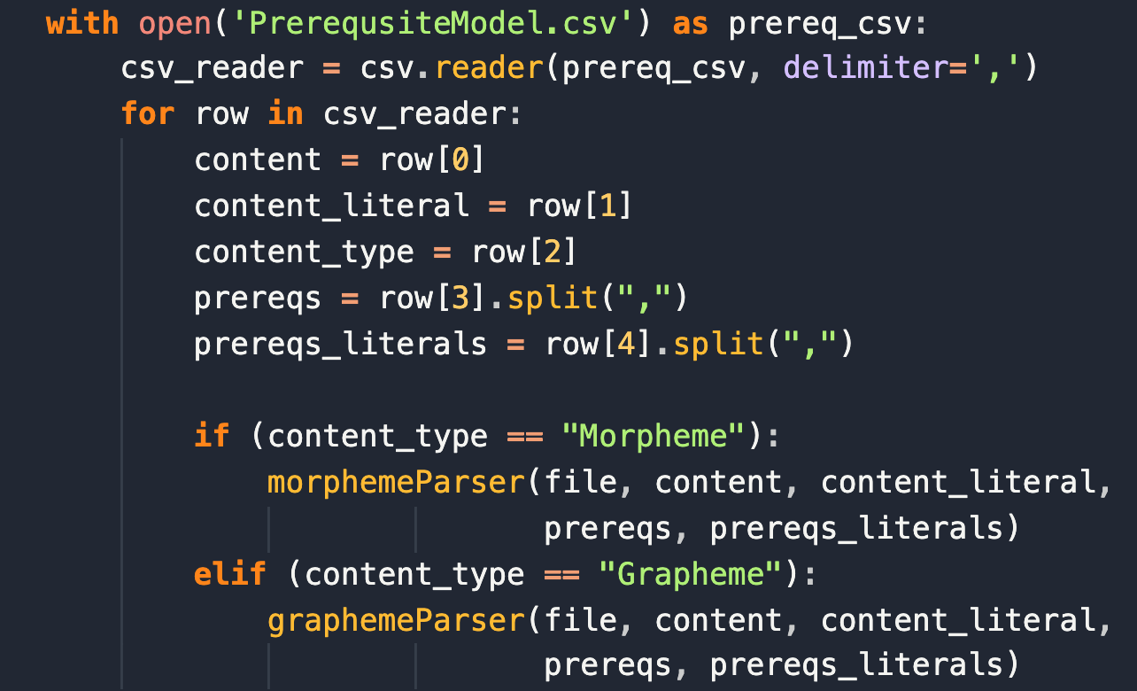

**Step 4:** upload the triples into GraphDB

QUESITON FOR THE MEETING

1. Is this still the best way to represent our triples?

1. What Needs to be preloaded into the Standard Content Before we dynamically upload new content?
2. Can we create a standard naming scheme for everyone that makes it easy to perform node-level integration and to make new triples?

For example, This IRI is hard to dynamically generate unless we still its values in the memory of our code

Possible Solutions: Naming the glyphs so there they show what phoneme and Grapheme they relate to 

1. Some of the Grapheme, Specifically the diagraphs and trigraphs, do not have a phoneme. Should we create a new IRI for these 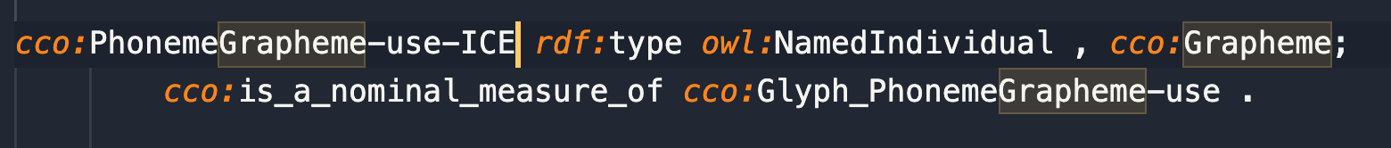
2. Can we add inverse relationship for all predicates?